Setting Up Performance Testing in Jmeter
Step:1 Install Java 8 or Higher Version
Step:2 Install Jmeter from apache: https://jmeter.apache.org/download_jmeter.cgi
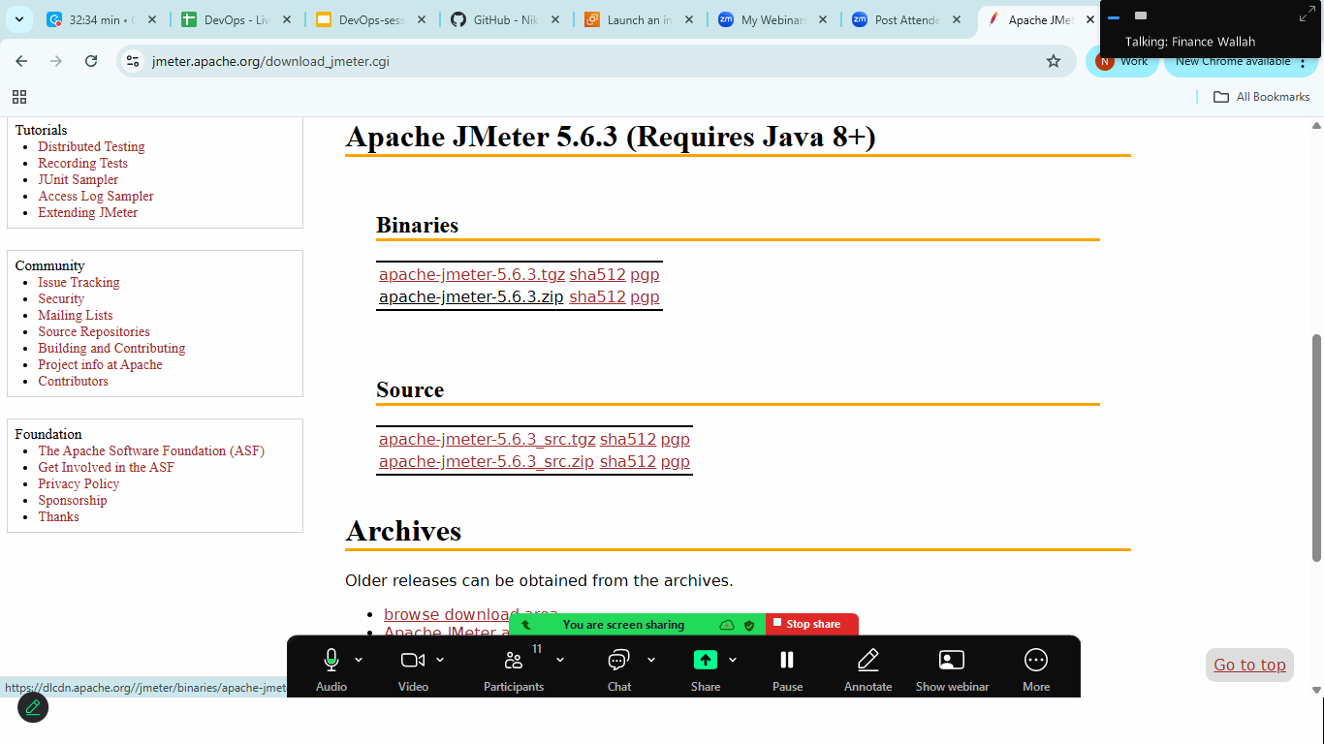
Download Zip from binary section

Step:3 extract it> goto> bin folder> double clikc on jmeter.bat file
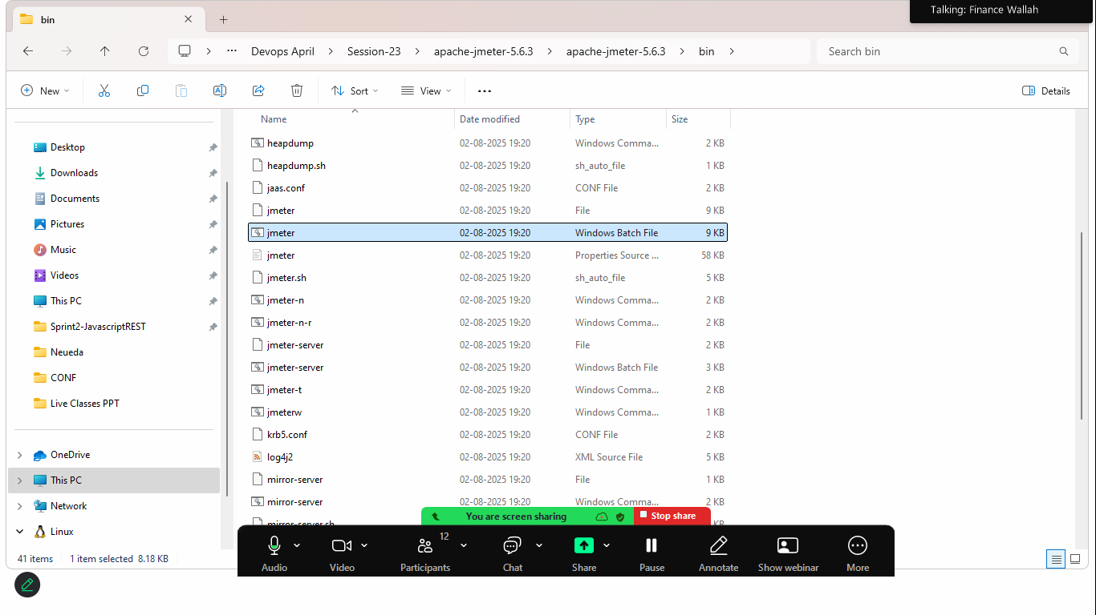
Step:4 Wait for few seconds to start jmeter & You will be onborded to apache jmeter dashboard
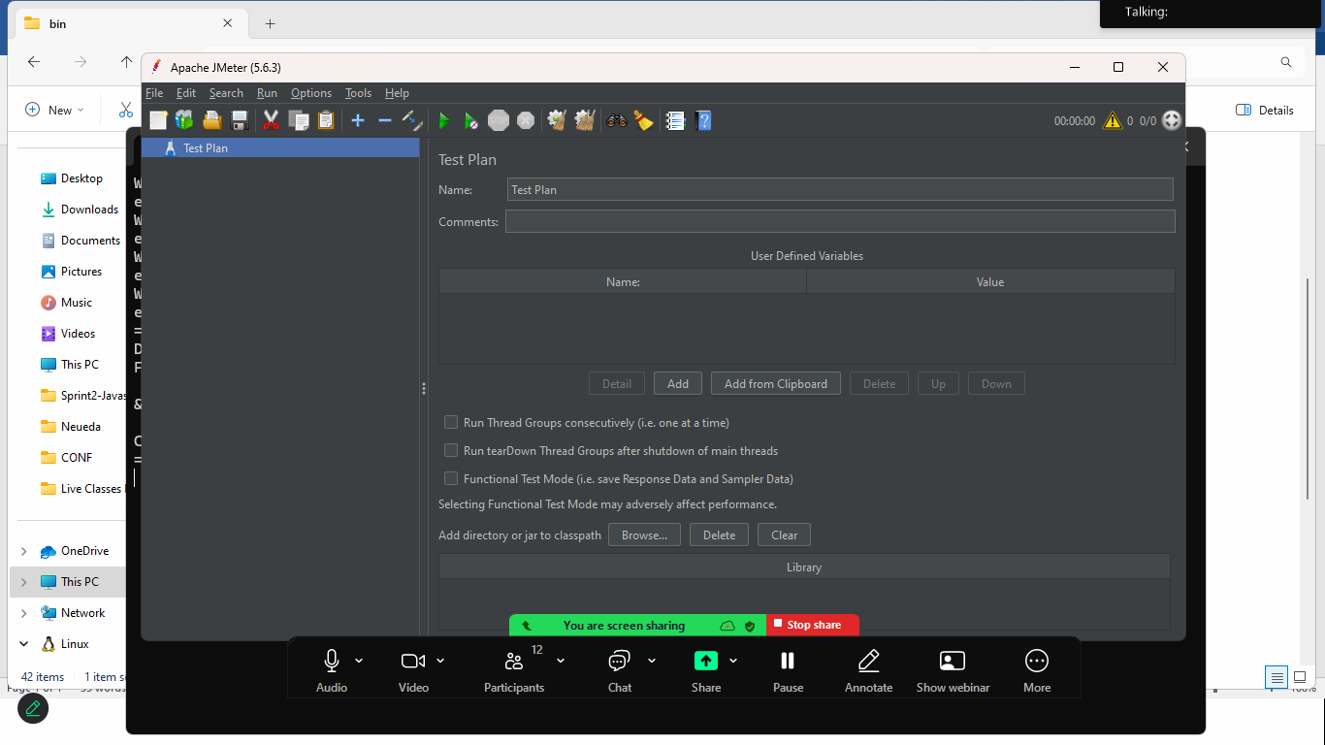
Right click to Basic Load Test> Threads>ThreadGroup
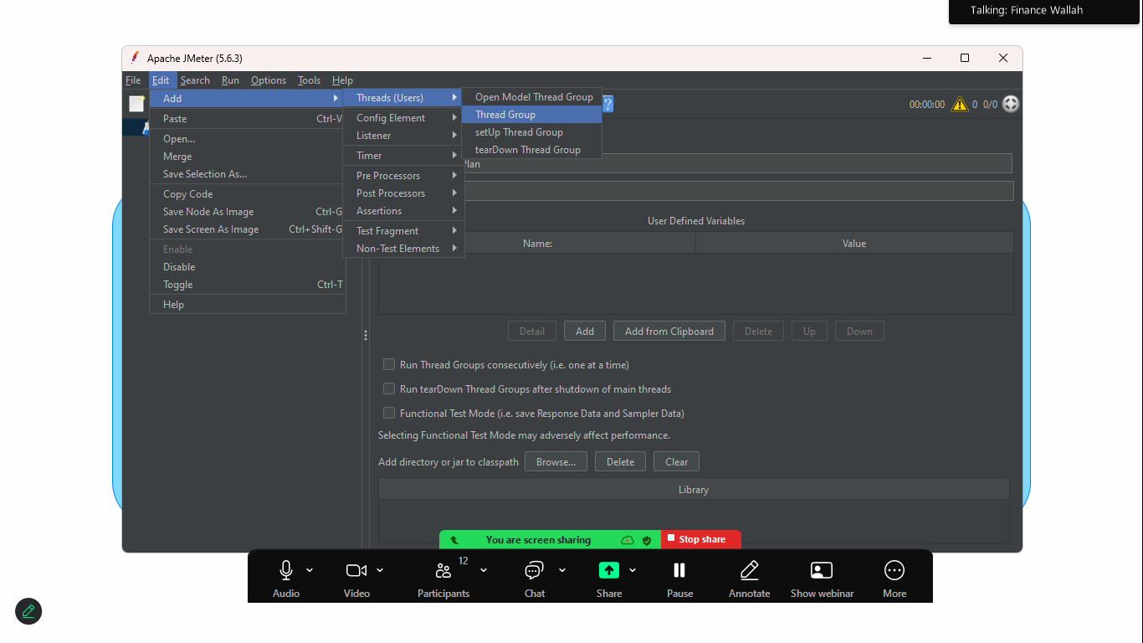
Set the Number of Thread(users):10
Ramp-Up Period(in seconds): 5 (jmeter will start 2 users per seconds
Lopp Count: 1 (each users will make 1 request)

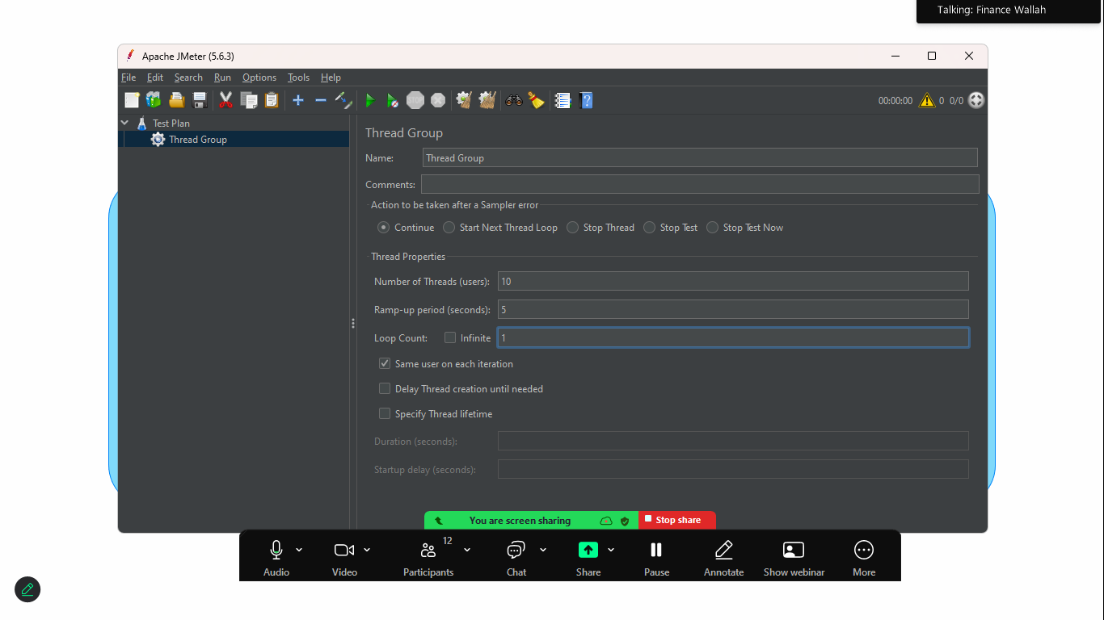

Add the HTTP Request Sample
Right clikc on Thread Group> add> sample >HTTP Request
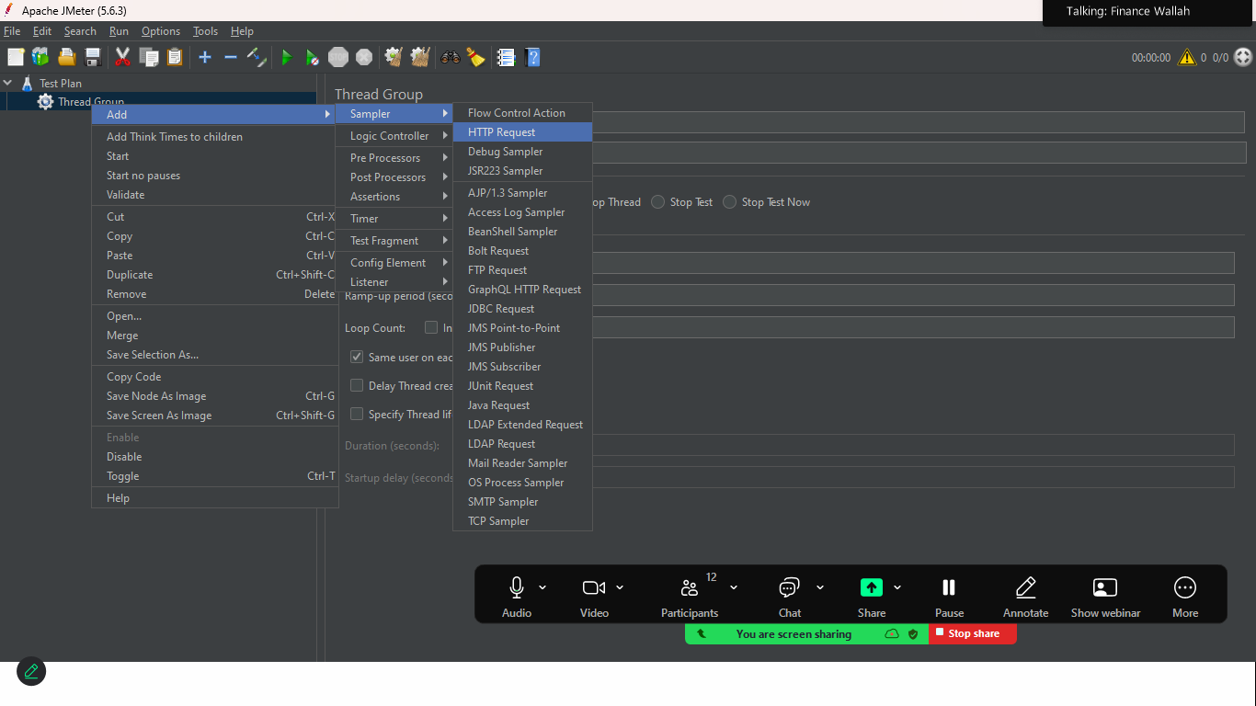

Provide your domain name / api 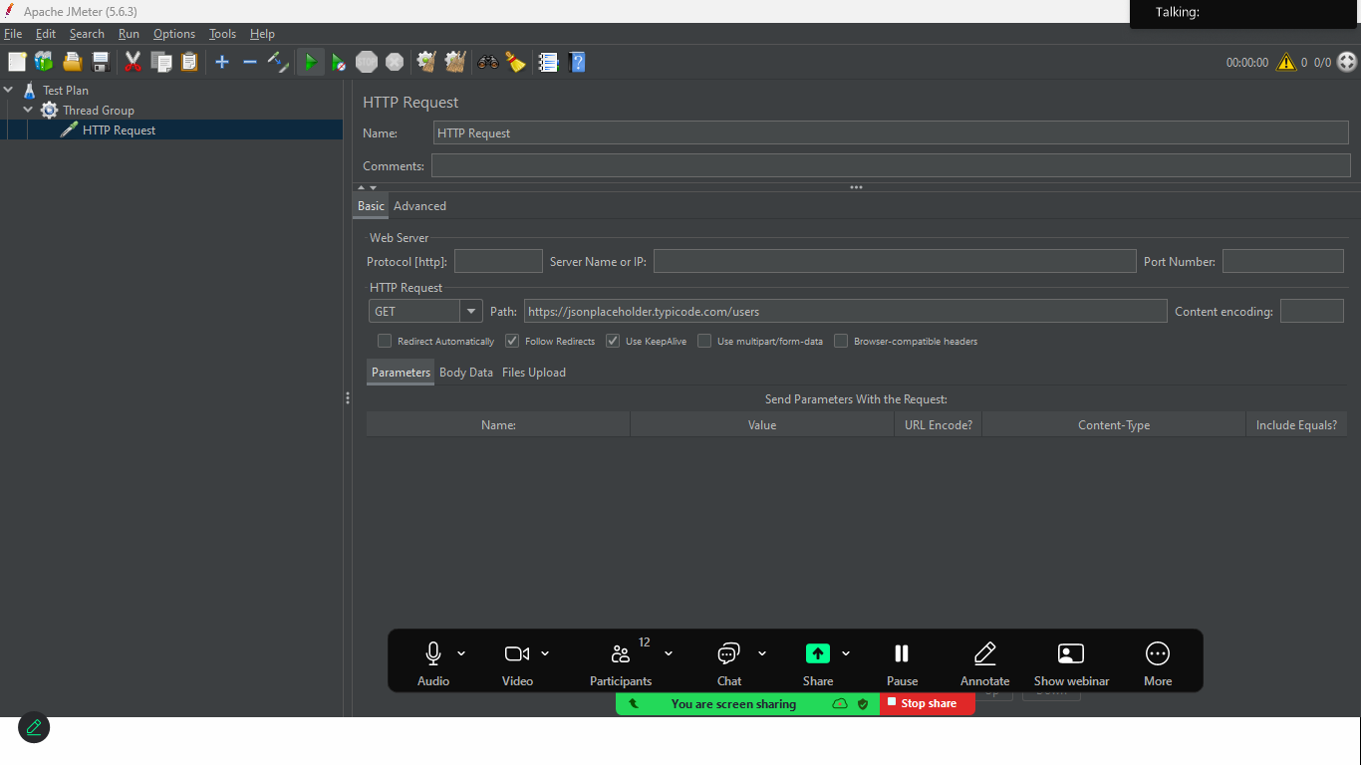

Click on start button
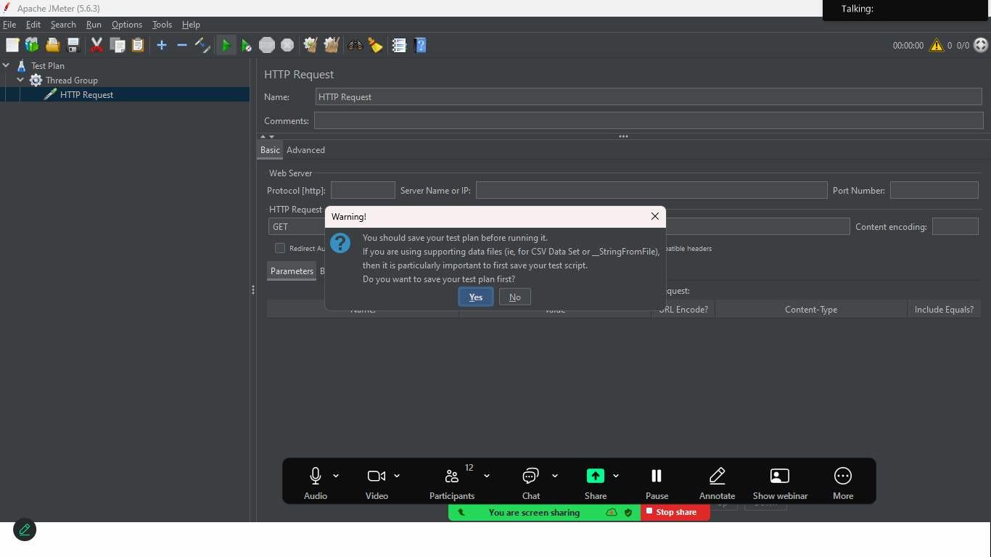
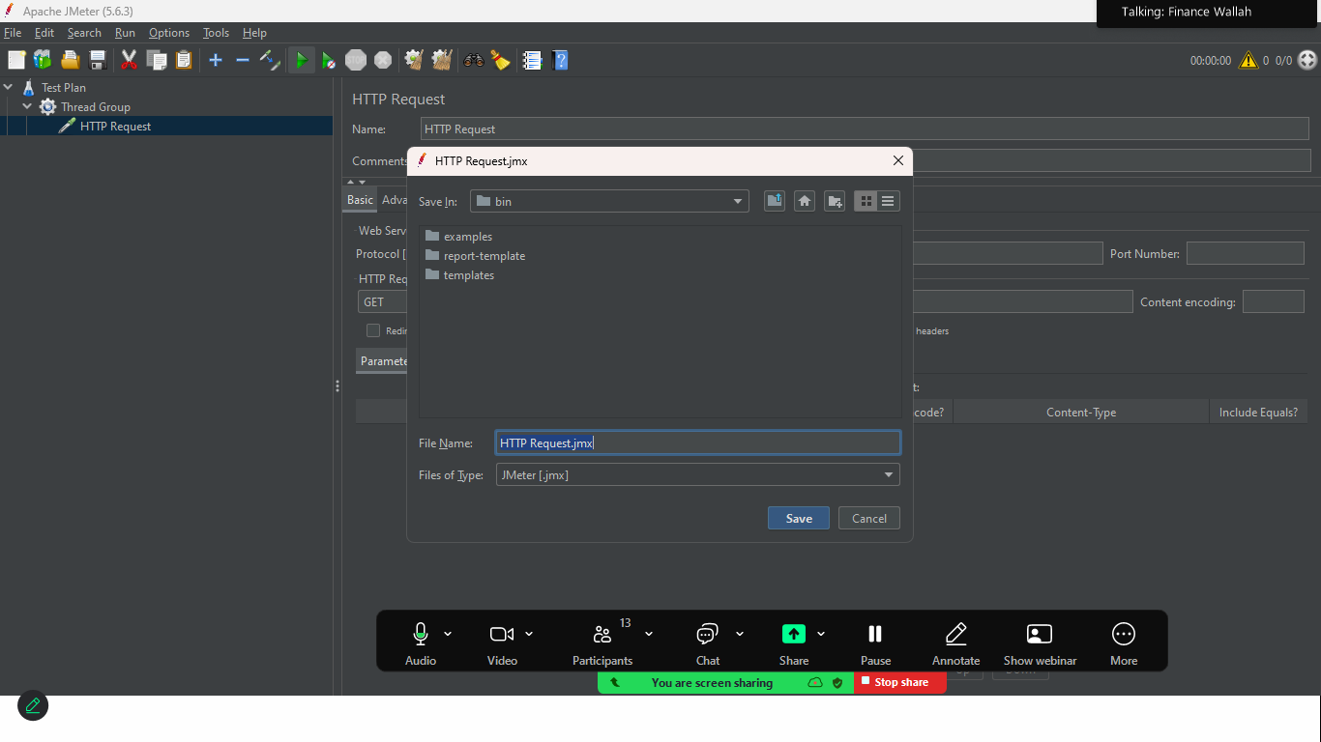
Right click to threadGroup>Listner> View result in Table
